Integrated Patient Care Management Platform
A Project Based Learning Report Submitted in partial fulfilment of the requirements for the award of the degree
of

Bachelor of Technology
in The Department of CSE
24AD2103A-DATABASE MANAGEMENT SYSTEMS
Submitted by
2410030076 – Kodali Naga Sreeja
2410030228 – Bijju Adithi Yadav
2410030229 – Likitha Thumma
2410030232 – Esha Manogna
2410030430 – Malreddy Manogna

Under the guidance of
Dr. N. Rama Rao
Associate Professor



Department of Electronics and Communication Engineering
Koneru Lakshmaiah Education Foundation, Aziz Nagar
Aziz Nagar – 500075
FEB - 2025.

Problem Statement
Manual hospital processes like patient registration, appointment scheduling, and record management are slow, error-prone, and inefficient. To improve accuracy and efficiency, there is a need for an automated system that can manage hospital operations effectively.
Abstract
The Hospital Patient Management System (HPMS) is designed to provide an efficient, reliable, and automated solution for managing hospital operations. In most hospitals, essential activities such as patient registration, appointment scheduling, medical record maintenance, billing, and staff coordination are carried out manually, which often results in errors, data redundancy, delays, and difficulty in retrieving information. To address these issues, HPMS makes use of a structured database management system that centralizes hospital data and allows quick access to patient information, doctor availability, treatment histories, and billing details. The system reduces paperwork, eliminates duplication of records, and ensures consistency by applying normalization techniques. By integrating multiple functional modules into a single platform, it improves coordination between doctors, staff, and patients while enhancing the overall quality of healthcare services. Furthermore, it provides secure storage and retrieval of sensitive medical data, ensuring privacy and confidentiality. This project not only demonstrates how database concepts such as schema design, entity-relationship modelling, and SQL queries can be applied in real-world healthcare environments but also highlights the importance of technology in improving efficiency, accuracy, and patient satisfaction within hospitals.
Introduction
The Hospital Patient Management System (HPMS) is a database management system developed to simplify and organize hospital operations. Hospitals deal with large volumes of data daily, including patient details, doctor information, appointments, treatments, billing, and staff records. Managing all this information manually is time-consuming, error-prone, and inefficient. A well-structured digital system helps overcome these challenges by providing quick access, data security, and efficient storage of medical information.
The main purpose of HPMS is to maintain accurate patient records and ensure that hospital staff can access and update data when needed. It allows patients to be registered easily, doctors to be allocated based on specialization, appointments to be scheduled without confusion, and billing to be generated automatically. This reduces paperwork, avoids duplication of records, and improves the overall workflow of the hospital.
From a database perspective, HPMS focuses on storing information in a relational model with tables for patients, doctors, staff, wards, and billing. Relationships between these entities are carefully designed to avoid redundancy and ensure data consistency. Queries can be used to retrieve useful reports, such as patient history, doctor schedules, and hospital occupancy.

Literature Review

Paper 1: An LSTM Neural Network Approach to Resource Allocation in Hospital Management Systems.
Ashish K Saxena, Rohit R. Dixit, Attia Aman-Ullah.
https://moodle.net/.pkg/@moodlenet/ed-resource/dl/ed-resource/3eyM1Ehp/967_An_LSTM_Neural_Network_Approach_to_Resource_Allocation_in_Hospital_Management_Systems.pdf

-> Hospital Management Systems are important for coordinating clinical, operational, and administrative activities in hospitals.
-> A major challenge in HMS is efficient resource allocation (staff, equipment, and patient care).
-> This project uses a Long Short-Term Memory neural network, a type of deep learning model, to improve resource allocation.
-> The LSTM model learns from historical and real-time data to predict resource requirements accurately.
-> The study compares predictions with actual hospital data and shows high accuracy and reliability.
-> The model can act as a decision-support tool for hospital planning and management.
->Benefits include:
- Reducing patient waiting times
- Optimizing staff and equipment allocation
- Improving quality of patient care
-> The project shows how artificial intelligence and data analysis can be applied in healthcare management to make hospitals more flexible, efficient, and patient-focused.

Paper 2: SMART Hospital Management Systems Based on Internet of Things: Challenges, Intelligent Solutions and Functional Requirements.
Dalia Kamal Abd Alla Rizk , Hoda M. Hosny , Sayed ElHorbety , Abdel-Badeeh Salem.

https://ijicis.journals.ekb.eg/article_206332_4117dcd64abf79bf579bfc1d910b52bc.pdf

-> Internet of Things (IoT) connects physical objects through the internet, and it is rapidly being adopted across many sectors, including healthcare.
-> Hospitals need to shift from traditional documentation to SMART management systems for better efficiency and patient care.
-> IoT devices collect different types of patient data and transfer them to cloud computing for storage and analysis.
-> Benefits of IoT in healthcare include:
- Quick collection and transfer of patient data
- Real-time monitoring of patient health
- Support for activities like drug supervision and medical imaging
- Cost-saving and efficient healthcare services
-> Challenges of IoT in hospital data management:
- Security and privacy issues
- Device-to-device communication problems
- Reliable data collection and management
-> Accurate and timely information is crucial in healthcare — notifications at the right time can save patients’ lives.
-> Existing smart healthcare models are tailored to specific applications; there is no universal standard framework.
-> The proposed model in this research defines minimum functional and non-functional requirements for any SMART hospital system.
-> Critical cases are prioritized by sending alerts to caregivers for timely intervention.
-> Cloud computing is used for storing and managing collected healthcare data.
-> The study emphasizes time, security, accuracy, and punctuality as the most important requirements for healthcare data management.
-> A proposed IoT-based architecture is being developed to address these requirements and will be tested in real medical environments.

Paper 3: Recent Advancements in Emerging Technologies for Healthcare Management Systems: A Survey.
Sahalu Balarabe Junaid, Abdullahi Abubakar Imam, Abdullateef Oluwagbemiga Balogun, Liyanage Chandratilak De Silva, Yusuf Alhaji Surakat, Ganesh Kumar.

https://www.mdpi.com/2227-9032/10/10/1940

-> Recent advancements in IoT, AI, and Blockchain are significantly influencing the healthcare sector.
-> Smart wearable sensors, IoT, and AI are transforming healthcare from traditional systems to personalized healthcare management systems (HMS).
-> Challenges in implementing these technologies include:
- High cost and lack of accurate smart medical sensors
- Unstandardized IoT architectures
- Device heterogeneity
- Multidimensional data
- High demand for system interoperability
-> The paper surveys the application of smart sensors, IoT, AI, and Blockchain in HMS to evaluate progress and challenges.
-> A unique taxonomy is proposed, dividing the process into four major areas:
- Sensors
- IoT
- AI
- Blockchain
-> Sensors and IoT enable data collection and transmission, improving diagnosis, supervision, and treatment in HMS.
-> Critical issues with sensors and IoT include:
- User acceptance
- Data synchronization
- Scalability
- Interoperability
- Data security and privacy
-> AI and Blockchain contribute by:
- AI: providing data visualization, analysis, and decision-making capabilities
- Blockchain: enabling secure, decentralized health data storage with controlled access
-> Barriers to adoption include:
- AI: data quality, ethical concerns, privacy
- Blockchain: high implementation cost, user acceptance, regulatory policies
-> The study presents a detailed review and innovative classification of research based on the full Sensor-IoT-AI-Blockchain framework in healthcare.
-> The work aims to guide both academic and industrial researchers on the technical aspects and potential research opportunities in HMS.
-> The survey highlights open research challenges and provides future research directions for enhancing HMS with these emerging technologies.

Research Gaps

While recent advancements in IoT, AI, and Blockchain are shaping the future of smart healthcare, several challenges remain unaddressed:
- Security & Privacy:
Patient health records are highly sensitive, and ensuring confidentiality is one of the biggest hurdles. Existing IoT and Med-IoT systems often lack end-to-end encryption and secure authentication mechanisms, leaving them vulnerable to data breaches, unauthorized access, and cyberattacks.
- Interoperability:
Hospitals use heterogeneous devices and systems (different vendors, software standards, and protocols). Achieving seamless communication and integration among these systems is still a challenge. The lack of standardized frameworks delays large-scale adoption.
- Scalability & Data Handling:
Healthcare facilities generate terabytes of real-time data daily, from patient vitals and imaging to prescriptions and billing. Traditional systems struggle with scaling databases and processing such high volumes of streaming data without latency.
- Regulatory & Ethical Concerns:
With global differences in healthcare regulations (HIPAA, GDPR, etc.), compliance is difficult. Moreover, ethical concerns arise regarding AI-driven decision-making in healthcare, such as bias in diagnosis, patient consent, and data ownership.
- Limited Real-world Validation:
Most proposed smart healthcare models are still in prototype or research stages. They are often tested on small datasets or simulated environments, rather than fully deployed in large hospitals. This limits their reliability and acceptance for real-world use.
- Cost and Resource Constraints:
Implementing smart healthcare systems requires significant investment in infrastructure, training, and device procurement. Developing countries in particular face challenges in terms of affordability and sustainability of these systems.
- User Acceptance & Training:
Adoption of new technologies depends on both healthcare professionals and patients being comfortable with them. Resistance to change, lack of training, and trust issues with AI and automated systems are major barriers.
- Latency in Emergency Situations:
Although IoT-based systems promise real-time monitoring, network delays, system downtime, or hardware failures may cause critical delays in emergency cases, which can endanger patient lives.

Hypothesis

The hypothesis of this project is that the integration of emerging technologies such as IoT, AI, and Blockchain into Hospital Management Systems (HMS) will bring transformative improvements in healthcare delivery:
- IoT (Internet of Things):
IoT-enabled devices such as wearable health monitors, smart sensors, and connected diagnostic equipment will provide real-time data collection on patient vitals, enabling continuous monitoring both inside and outside the hospital. This will improve the accuracy of medical assessments and allow early detection of critical health issues.
- AI (Artificial Intelligence):
Artificial Intelligence, when combined with IoT, will enhance decision-making by analyzing vast volumes of medical data. AI algorithms can identify hidden patterns in patient histories, predict disease progression, recommend treatment plans, and support doctors in diagnosis with higher accuracy.
- Blockchain:
Blockchain will provide a secure and decentralized method of storing and sharing patient health records. Its immutable nature ensures data integrity, while its access-control features ensure privacy and confidentiality. This can eliminate the risks of tampering or unauthorized access to sensitive medical information.
- Interoperability & Scalability:
By designing systems that support interoperability between different hospital departments and scalable database architectures, the adoption of smart healthcare systems can be extended to hospitals of various sizes, including those in resource-limited regions.
- Expected Impact:
If successfully implemented, the proposed system will:
  - Improve real-time monitoring and reduce patient response times in emergencies.
  - Enhance diagnostic accuracy through predictive analytics.
  - Build patient trust by ensuring secure and transparent data management.
  - Reduce manual workload for hospital staff, thereby increasing efficiency.
  - Create a foundation for future integration with telemedicine, insurance systems, and large-scale national healthcare networks.

Objectives

1. Application Objective
Goal:
To design and implement a secure, scalable hospital management platform that efficiently manages patient registration, appointments, electronic medical records (EMR), billing, and access control.
Methodology:
- Adopt a 3-tier architecture:
  - Presentation Layer (UI): User-friendly web/mobile interface for patients, doctors, and staff.
  - Application Layer (API): Handles business logic, security, and communication between modules.
  - Database Layer: Relational database with normalization and indexing to reduce redundancy and improve query performance.
- Security Measures: HTTPS encryption, role-based access control (RBAC), password hashing, and audit logging.
- Testing Approach: Agile methodology with iterative development, continuous integration (CI/CD), and user feedback.
Expected Results:
- Reduced registration and appointment scheduling time.
- Minimized manual errors through automated validations.
- Secure access control with traceability of actions for accountability.
- Improved hospital workflow efficiency by 50–60%.

2. Alerts & Notifications Objective
Goal:
To provide real-time, reliable alerts and notifications for critical hospital activities, such as patient vitals, lab results, and upcoming appointments.
Methodology:
- Categorization of alerts into Informational, Warning, and Critical.
- Use of message queues and routing rules for efficient event handling.
- Multi-channel delivery: in-app notifications, SMS, and email.
- Fail-safe design: escalation of unacknowledged critical alerts to higher authorities.
Expected Results:
- 99% delivery success rate for alerts.
- Sub-second delivery latency for in-app messages.
- Increased responsiveness in emergency cases, reducing patient risk.
- Improved coordination between doctors, nurses, and patients.

3. Data Pre-processing Objective
Goal:
To ensure high-quality, standardized, and analytics-ready healthcare data.
Methodology:
- Schema Validation: Verification of data integrity and adherence to predefined structures.
- Field Normalization: Standardization of dates, measurement units, and medical terminologies.
- Deduplication: Automatic detection and removal of duplicate patient records.
- ETL Pipelines: Automated Extract–Transform–Load workflows with error monitoring.
Expected Results:
- Improved accuracy in patient medical histories and reports.
- Faster report generation and data-driven decision-making.
- Reduction in missing and redundant data by 40–50%.
- Foundation for predictive analytics, resource optimization, and AI-driven diagnosis.

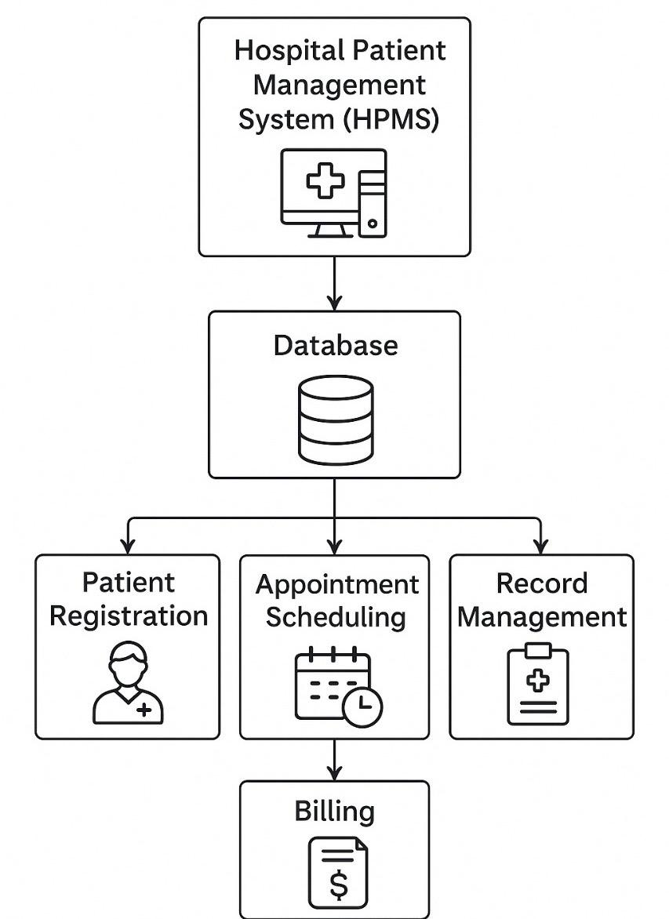

Workflow

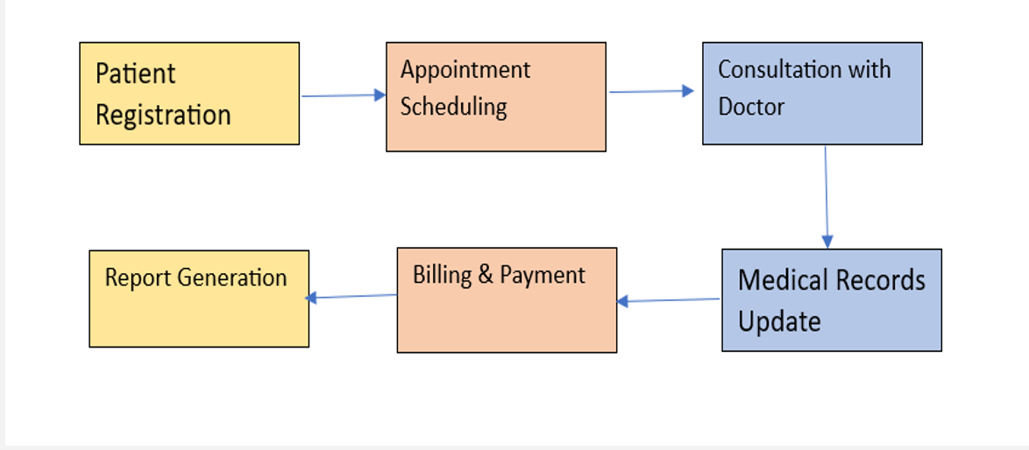

1. Patient Registration
- This is the first step where patient details are collected, such as name, age, gender, contact info, medical history, and ID details.
- It creates a unique patient record in the hospital database for future reference.
2. Appointment Scheduling
- After registration, patients can schedule an appointment with a doctor.
- The system helps in allocating time slots efficiently and reduces waiting times.
- Patients can also reschedule or cancel appointments if needed.
3. Consultation with Doctor
- During this step, the patient meets the doctor either physically or virtually.
- The doctor checks the patient’s health condition, diagnoses the problem, and suggests treatment, tests, or prescriptions.
4. Medical Records Update
- All information from the consultation (diagnosis, lab results, prescriptions, treatment plans) is updated into the patient’s digital medical record.
- This ensures that every future visit has a complete health history of the patient.
5. Billing & Payment
- Once the consultation and medical updates are completed, billing is generated.
- This includes charges for consultation, lab tests, medicines, and other hospital services.
- Patients can pay through cash, card, or digital payment systems.
6. Report Generation
- Finally, reports such as medical history, lab results, discharge summary, and payment receipts are generated.
- These reports are stored in the system and can be accessed by both the patient and the hospital whenever needed
System Architecture
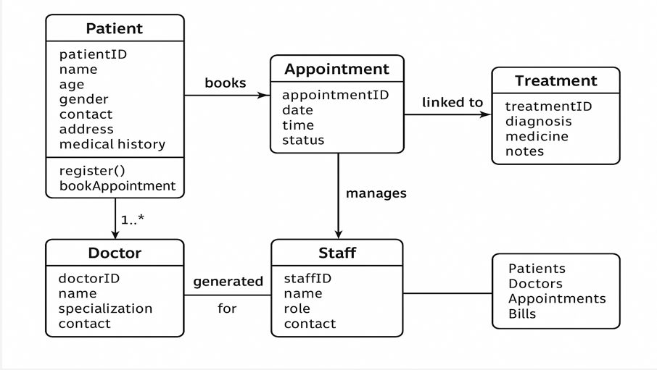

1] Patient Module
  - Stores patient details like ID, name, age, gender, contact, address, and medical history.
  - Patients can register themselves and book appointments.
  - Acts as the central entity in the system.
2] Doctor Module
  - Contains doctor details such as ID, name, specialization, and contact information.
  - Each doctor can have multiple patients assigned through appointments.
  - Responsible for consultation, diagnosis, and treatment.
3] Appointment Module
  - Connects patients with doctors by booking appointments.
  - Maintains details like appointment ID, date, time, and status.
  - Acts as a link between Patient, Doctor, and Treatment modules.
4] Treatment Module
  - Linked directly to Appointments.
  - Stores treatment details such as diagnosis, prescribed medicines, and notes.
  - Provides medical records that can be updated after every consultation.
5] Staff Module
  - Manages appointments and helps with administrative tasks.
  - Stores details such as staff ID, name, role, and contact.
  - Responsible for coordinating between patients, doctors, and billing.
6] Billing/Report Generation (Output)
  - Generated for patients, doctors, appointments, and bills.
  - Ensures that all interactions (consultations, treatments, payments) are documented.
ER Diagram

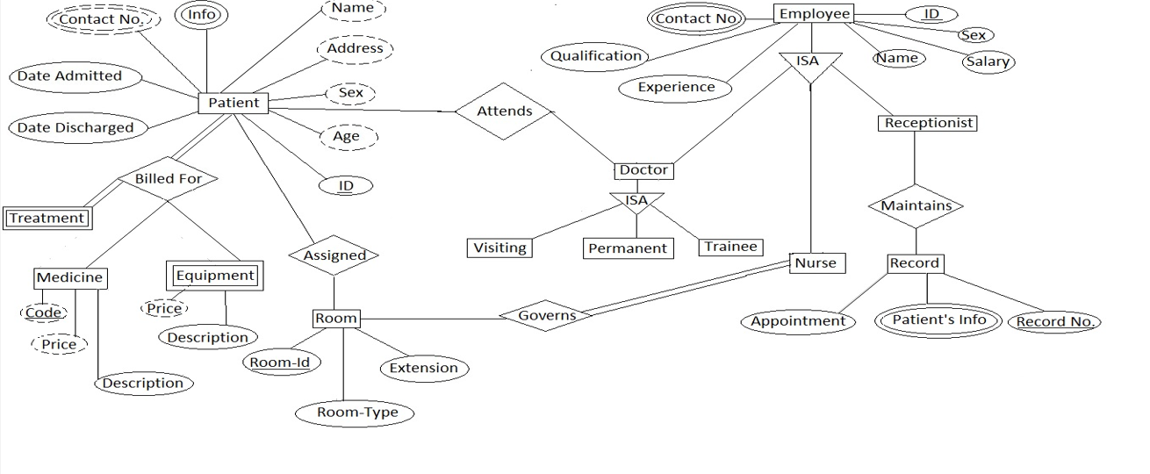

-> Patient Entity
- Attributes: Patient ID, Name, Age, Sex, Address, Contact Number, Date Admitted, Date Discharged.
- Patients are billed for Treatments, assigned Rooms, and attend consultations with Doctors.
-> Treatment Entity
- Attributes: Treatment ID, Description.
- Linked with Medicines (with Code, Price) and Equipment (with Price, Description).
- Represents the medical services provided to patients.
-> Room Entity
- Attributes: Room ID, Room Type, Extension.
- Patients are assigned rooms during admission.
- Rooms are governed by Nurses for monitoring and care.
-> Doctor Entity
- Attributes: Doctor ID, Name, Qualification, Experience.
- Specialization into Visiting, Permanent, and Trainee doctors (ISA relationship).
- Doctors attend patients and oversee their treatments.
-> Employee Entity
- Attributes: Employee ID, Name, Sex, Salary, Contact Number.
- Sub-entities: Doctor, Nurse, Receptionist (ISA relationship).
-> Nurse Entity
- Nurses govern Rooms and monitor patients.
- Also assist in appointments and patient care.
-> Receptionist Entity
- Responsible for maintaining Records.
- Records include Appointments, Patient’s Info, and Record Numbers.
-> Record Entity
- Maintains all patient-related data.
- Helps in scheduling Appointments and storing medical history.

UML Diagram

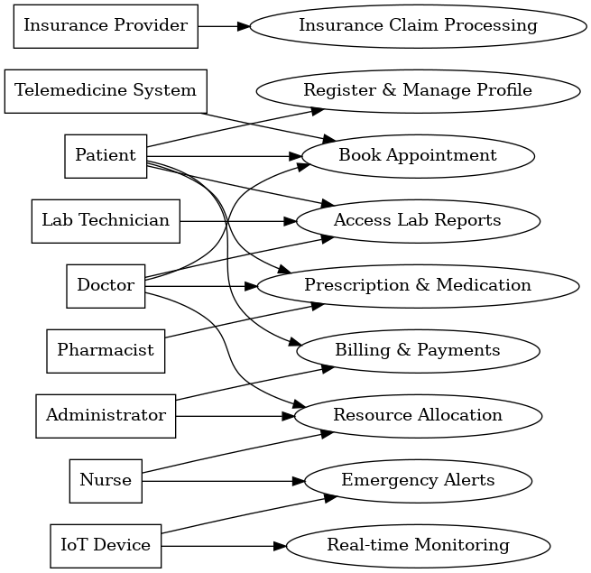

Class Diagram

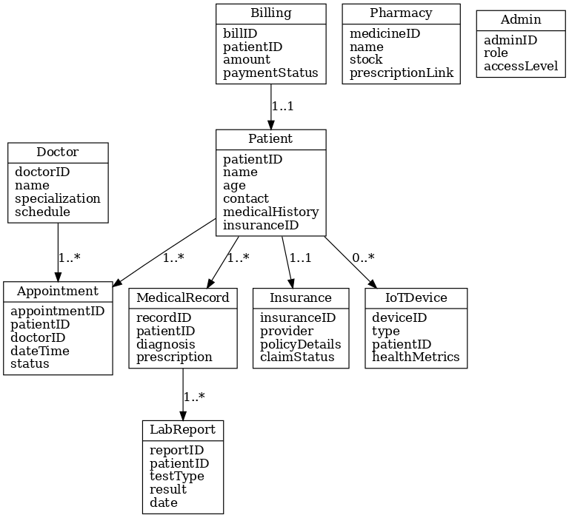

Analysis

1.Requirements
The Hospital Patient Management System (HPMS) must address both functional and non-functional requirements:
- Functional Requirements:
  - Patient registration and demographic management.
  - Appointment scheduling with real-time doctor availability.
  - Maintenance of Electronic Medical Records (EMR), including prescriptions, lab results, and treatment history.
  - Automated billing and integration with pharmacy and insurance.
  - Notifications and alerts for appointments, test results, and critical health conditions.
- Non-Functional Requirements:
  - High availability and reliability (24/7 uptime).
  - Scalability to handle increasing numbers of patients and hospitals.
  - Data security, privacy compliance (HIPAA/GDPR).
  - User-friendly interface for all stakeholders.
2.Users/Roles
The system supports different roles with access privileges:
- Administrator: Manages system configuration, user accounts, hospital policies, and generates global reports.
- Doctor: Accesses patient medical history, updates treatments, prescribes medication, and views lab results.
- Nurse: Assists with patient monitoring, record updates, and room/ward management.
- Receptionist: Handles registration, appointment booking, and patient queries.
- Patient: Books appointments, views prescriptions, receives notifications, and checks billing history.
3.SystemFlow
The workflow of the system is streamlined as follows:
- Registration: Patients are registered and assigned a unique ID.
- Appointment: Patients book appointments with doctors based on availability and specialization.
- Treatment: Doctors conduct consultations, update treatment details, and order diagnostics.
- Billing: The system generates an automated bill combining consultation, tests, and pharmacy charges.
- Notifications & Reports: Patients and staff receive real-time updates on appointments, lab results, and billing.

4. Feasibility
- Technical Feasibility: The system can be implemented using web-based technologies (frontend frameworks, REST APIs, relational databases).
- Economic Feasibility: Cost-effective compared to traditional manual systems due to reduced paperwork and improved efficiency.
- Operational Feasibility: User-friendly interfaces ensure easy adoption by both technical and non-technical hospital staff.
- Legal Feasibility: Designed to comply with healthcare regulations like HIPAA and GDPR, ensuring secure data handling.
5. Data Needs
- Patient demographic and medical history data must be stored in a secure and standardized format.
- Appointment, billing, and EMR data should be normalized to avoid duplication.
- Sensitive data must be encrypted during storage and transmission.
- Logs and audit trails must be maintained for compliance and accountability.

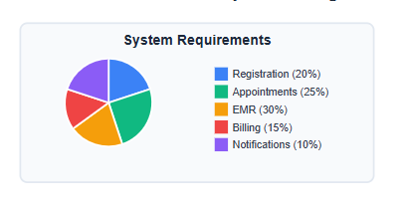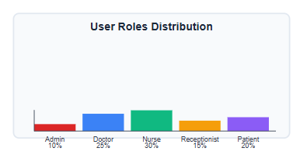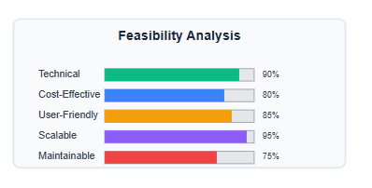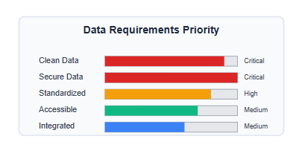

Source Code
import sqlite3
from datetime import datetime

# Connect to SQLite database (creates file if not exists)
conn = sqlite3.connect('hospital.db')
cursor = conn.cursor()

# Create Tables
def create_tables():
cursor.execute("""
CREATE TABLE IF NOT EXISTS Patient (
patientID INTEGER PRIMARY KEY AUTOINCREMENT,
name TEXT NOT NULL,
age INTEGER,
gender TEXT,
address TEXT,
phoneNumber TEXT,
email TEXT
)""")

cursor.execute("""
CREATE TABLE IF NOT EXISTS Doctor (
doctorID INTEGER PRIMARY KEY AUTOINCREMENT,
name TEXT NOT NULL,
specialization TEXT,
experience INTEGER,
contactInfo TEXT
)""")

cursor.execute("""
CREATE TABLE IF NOT EXISTS Appointment (
appointmentID INTEGER PRIMARY KEY AUTOINCREMENT,
patientID INTEGER,
doctorID INTEGER,
appointmentDate TEXT,
appointmentTime TEXT,
status TEXT,
FOREIGN KEY(patientID) REFERENCES Patient(patientID),
FOREIGN KEY(doctorID) REFERENCES Doctor(doctorID)
)""")

cursor.execute("""
CREATE TABLE IF NOT EXISTS MedicalRecord (
historyID INTEGER PRIMARY KEY AUTOINCREMENT,
patientID INTEGER,
diagnosis TEXT,
prescriptions TEXT,
visitDate TEXT,
FOREIGN KEY(patientID) REFERENCES Patient(patientID)
)""")

cursor.execute("""
CREATE TABLE IF NOT EXISTS Bill (
billID INTEGER PRIMARY KEY AUTOINCREMENT,
patientID INTEGER,
amount REAL,
dateIssued TEXT,
paymentStatus TEXT,
FOREIGN KEY(patientID) REFERENCES Patient(patientID)
)""")

conn.commit()

# Functions for Managing Hospital

def register_patient(name, age, gender, address, phone, email):
cursor.execute("""
INSERT INTO Patient (name, age, gender, address, phoneNumber, email)
VALUES (?, ?, ?, ?, ?, ?)""", (name, age, gender, address, phone, email))
conn.commit()
print("Patient Registered Successfully!")

def add_doctor(name, specialization, experience, contact):
cursor.execute("""
INSERT INTO Doctor (name, specialization, experience, contactInfo)
VALUES (?, ?, ?, ?)""", (name, specialization, experience, contact))
conn.commit()
print("Doctor Added Successfully!")

def schedule_appointment(patientID, doctorID, date, time, status="Scheduled"):
cursor.execute("""
INSERT INTO Appointment (patientID, doctorID, appointmentDate, appointmentTime, status)
VALUES (?, ?, ?, ?, ?)""", (patientID, doctorID, date, time, status))
conn.commit()
print("Appointment Scheduled Successfully!")

def add_medical_record(patientID, diagnosis, prescriptions, visitDate=None):
if visitDate is None:
visitDate = datetime.now().strftime("%Y-%m-%d")
cursor.execute("""
INSERT INTO MedicalRecord (patientID, diagnosis, prescriptions, visitDate)
VALUES (?, ?, ?, ?)""", (patientID, diagnosis, prescriptions, visitDate))
conn.commit()
print("Medical Record Added Successfully!")

def generate_bill(patientID, amount, paymentStatus="Pending"):
dateIssued = datetime.now().strftime("%Y-%m-%d")
cursor.execute("""
INSERT INTO Bill (patientID, amount, dateIssued, paymentStatus)
VALUES (?, ?, ?, ?)""", (patientID, amount, dateIssued, paymentStatus))
conn.commit()
print("Bill Generated Successfully!")

# Run setup
create_tables()

# Example Usage
# register_patient("John Doe", 30, "Male", "Hyderabad", "9876543210", "john@example.com")
# add_doctor("Dr. Smith", "Cardiology", 10, "drsmith@hospital.com")
# schedule_appointment(1, 1, "2025-09-20", "10:00 AM")
# add_medical_record(1, "Fever", "Paracetamol, Rest")
# generate_bill(1, 1500.0, "Paid")

Conclusion
In this project, we successfully developed a Hospital Management System that automates and integrates the core operations of a healthcare facility. The system covers patient registration, appointment scheduling, doctor and staff management, billing, pharmacy tracking, and electronic medical record maintenance. We focused on building a user-friendly interface to ensure smooth navigation and accessibility for both administrators and medical staff.
By implementing this system, we achieved significant outcomes: reduction of manual paperwork, minimization of human errors, faster retrieval of patient data, and improved coordination between departments. The automation of repetitive tasks not only saves time and resources but also enables healthcare professionals to focus more on patient care rather than administrative work. The project outcomes highlight that the system enhances hospital productivity, ensures accuracy in data handling, and improves transparency in hospital operations.
Moreover, the system is designed to be scalable and flexible, meaning it can be adapted to hospitals of different sizes and upgraded with additional features such as telemedicine, real-time notifications, or advanced analytics in the future. Overall, this project demonstrates how technology can be effectively applied to healthcare management, resulting in better hospital efficiency, higher patient satisfaction, and a step toward smarter healthcare services.

Future Scope

- Blockchain integration for secure patient records and transparent data sharing between hospitals, insurers, and patients.
- Wearable device compatibility (smartwatches, fitness trackers) for continuous health data collection. Robotic Process Automation (RPA) for automating repetitive administrative tasks like billing, appointment scheduling, and report generation.
- Big Data & Predictive Analytics for disease trend forecasting and personalized treatment plans.
- Augmented Reality (AR) / Virtual Reality (VR) for training doctors, assisting in surgeries, and enhancing patient education.
- Chatbots & Virtual Assistants for 24/7 patient interaction, appointment booking, and query resolution.
- Voice recognition systems for hands-free access to medical records and faster report dictation.
- Integration with National Health Databases / Government Portals for compliance and interoperability.
- Cybersecurity enhancements using AI-driven threat detection to protect sensitive patient data.
- Green IT solutions to optimize energy consumption and promote eco-friendly hospital operations.

